flops and params计算
FLOPs：注意s小写，是floating point operations的缩写（s表复数），意指浮点运算数，理解为计算量。可以用来衡量算法/模型的复杂度。
对于计算量主要有Madds和MFlops两个概念。shufflenet的论文用的是Flops，Mobilenet用的是Madds，Flops应该是Madds的两倍，具体可参考

mnist_cnn.py
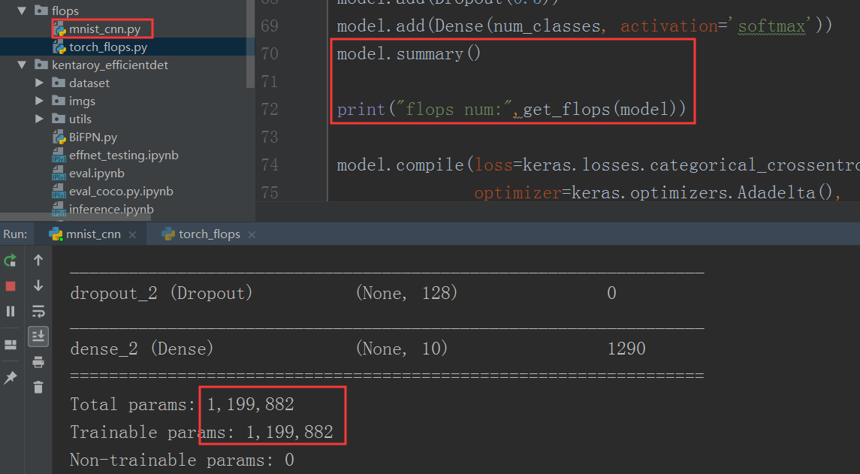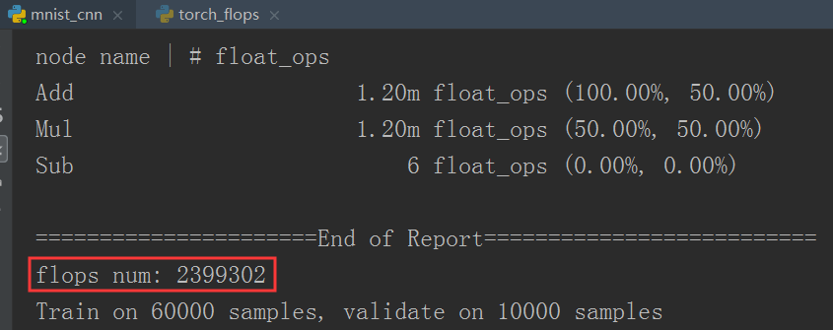
torch_flops.py
FLOPs与输入(1, 3, 224, 224)有关系，params与输入没有关系。
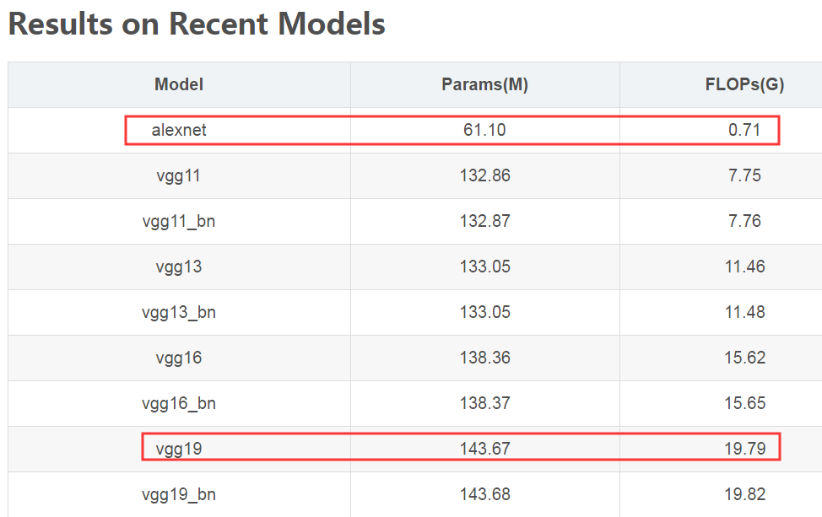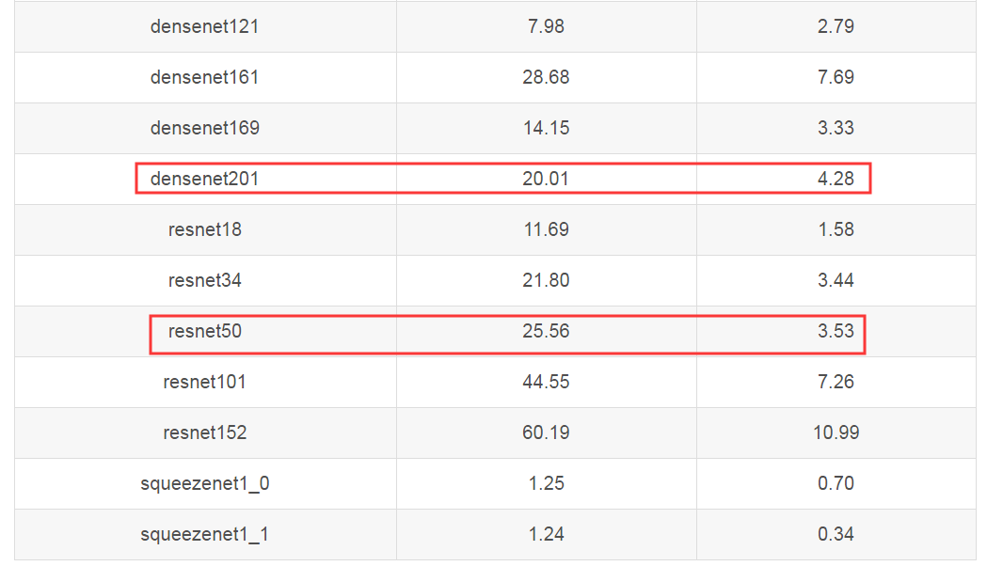
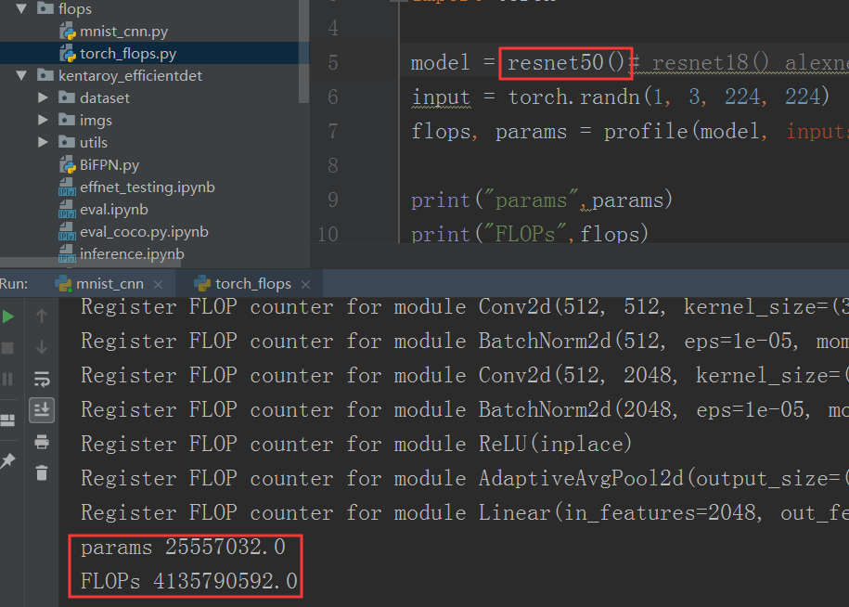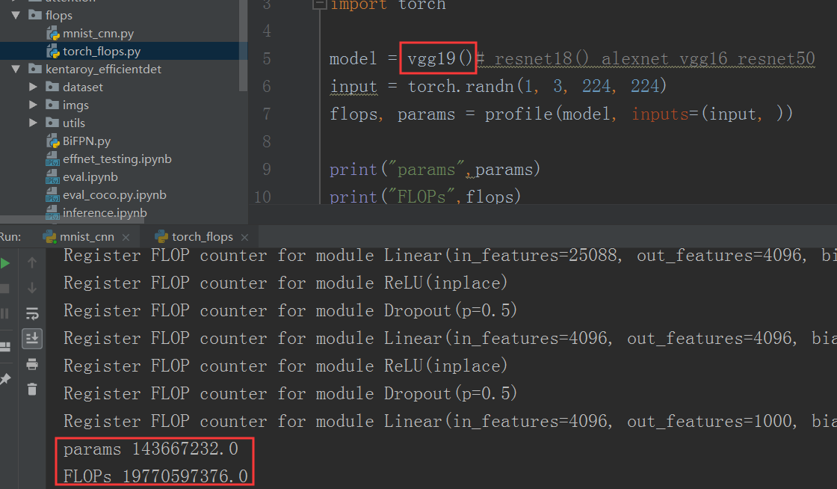
EfficientNet Rethinking Model Scaling for Convolutional Neural Networks
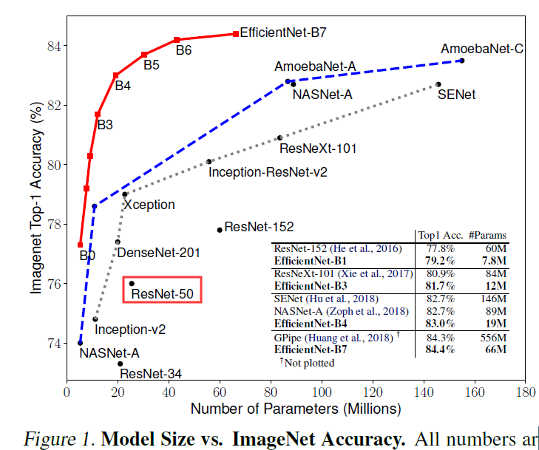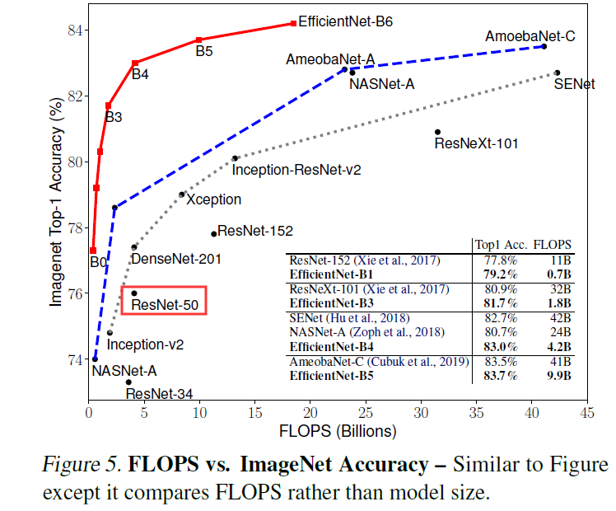

安装：
01
Win7 PC conda env desk-gpu
ModuleNotFoundError: No module named 'torch'
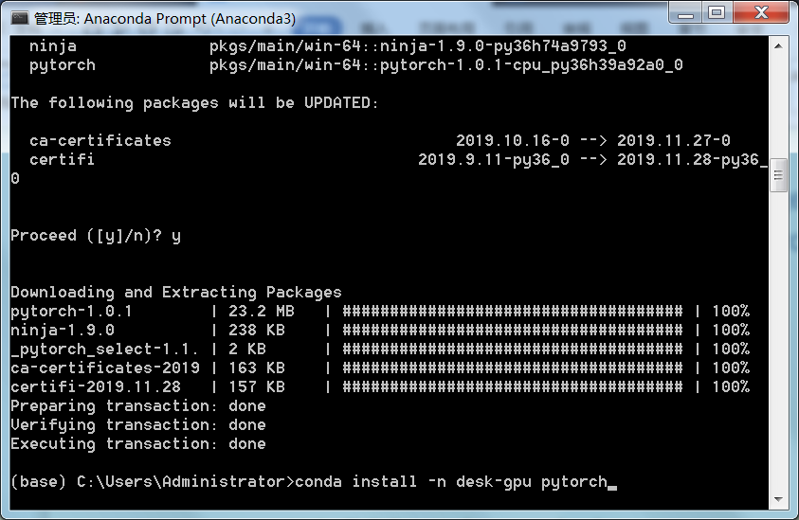
(base) C:\Users\Administrator>conda install -n desk-gpu pytorch
>conda list -n desk-gpu
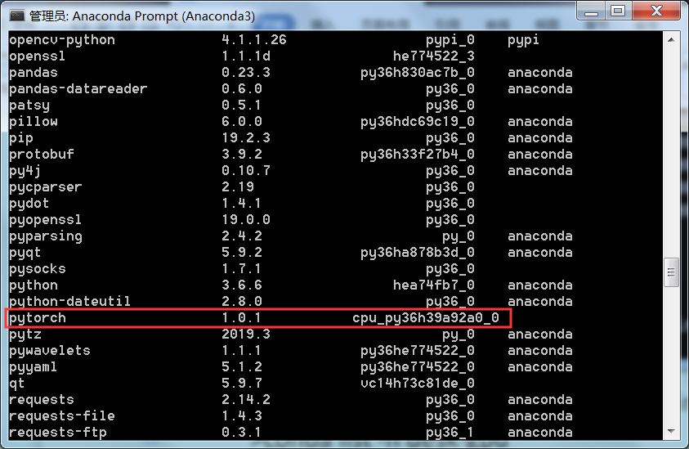

04.
Win7 PC conda env desk-gpu
ImportError: No module named torchvision
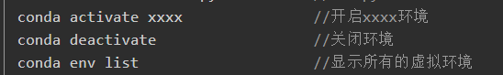
>conda activate desk-gpu
(desk-gpu) C:\Users\Administrator>pip install torchvision
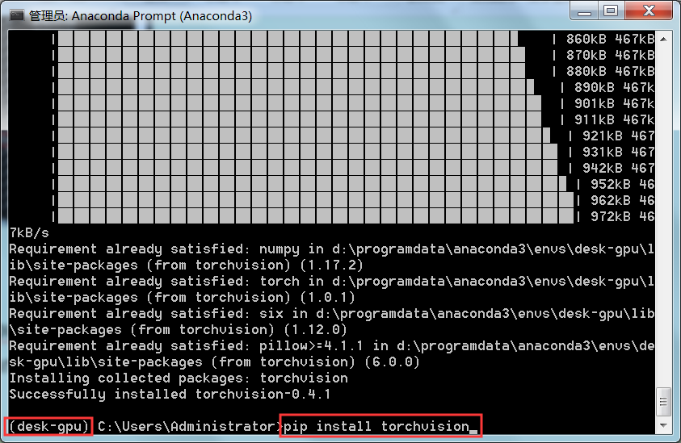 OK

03.
Win7 PC conda env desk-gpu
>conda activate desk-gpu
(desk-gpu) C:\Users\Administrator>pip install thop
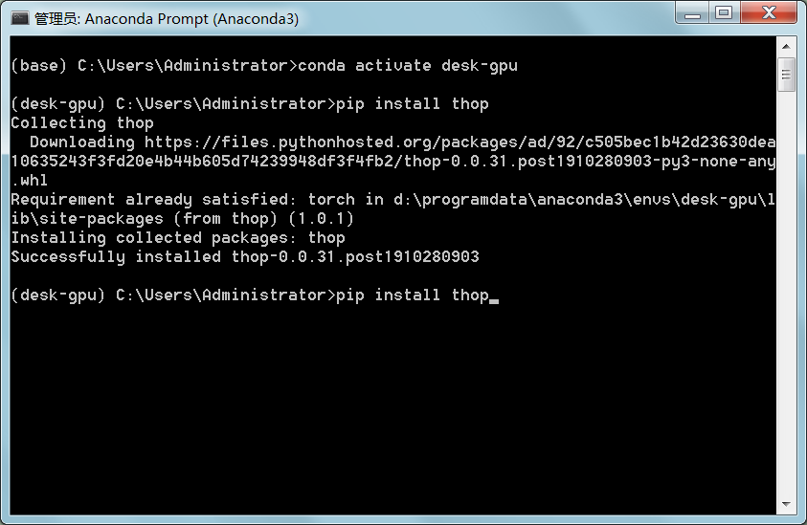 OK
参考：https://blog.csdn.net/hajungong007/article/details/90169808

04.
GPU noVNC py3
安装torch，下载不成功，无法安装。
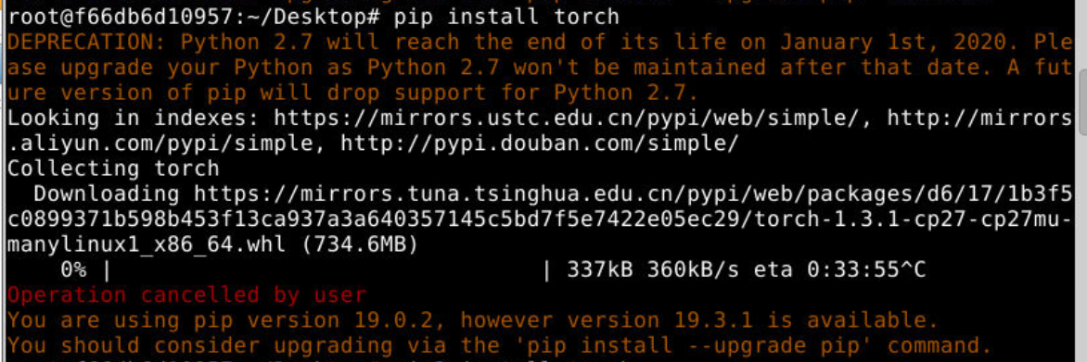

手动下载
安装
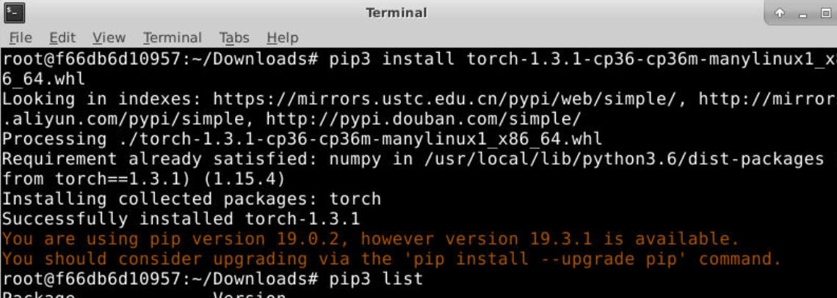
继续安装pip3 install torchvision
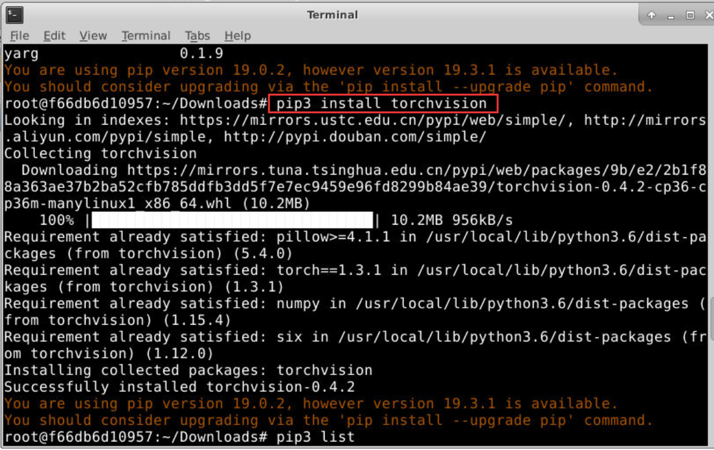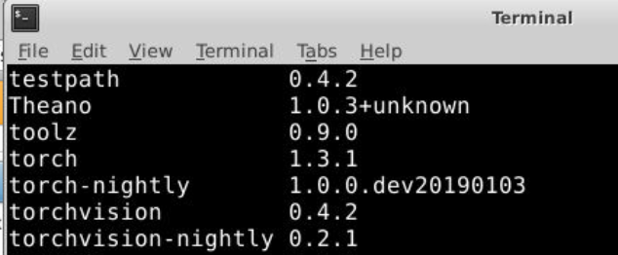
OK

参考：
https://www.baidu.com/link?url=ZcKLfdcjeeuiN8LEuuQ4Qb_v4Leyaw8Cy8EQr_RRrcWQJQ4JXJaxAPe_SgW_L46M5Y5hz5lcn_SDVdOAZnweV8y26Ra8txIsAlQglHuLtOC&wd=&eqid=c01c04eb00068f06000000025df33d0e
https://www.baidu.com/link?url=jR6ptAmnCHqp9242EcyNmc5KMH7JOUKpjAuisS7Q0Le9tc81q9gDlZanARJrXJRR1_A3bGHLLuiY3maOAqGPVq&wd=&eqid=c9abd3600009b309000000025df33d32
https://blog.csdn.net/sinat_34460960/article/details/84779219
https://blog.csdn.net/zt1091574181/article/details/97393278
https://www.baidu.com/link?url=aOAb97ZA_SvKlkcfowYY9i3HSoi7edZ3KAu-Mmx7Guyhr1oIVt2k08MNIELXU6ixRlo1hRhKkWcEYov3J6hG_NUJBJm_ZdVv0_bHS-X19D_&wd=&eqid=c01c04eb00068f06000000025df33d0e

